**CS2023 - Data Structures and Algorithms**

**In-class Lab Exercise**

Week 8

Submission by: Sajeev Kugarajah (210554M)

**GitHub repo link:**

<https://github.com/veejask-41/210554M-CS-2023-Data_Structures_And_Algorithms/blob/main/week%2008/lab%2008/heap.cpp>

**Terminal output:**

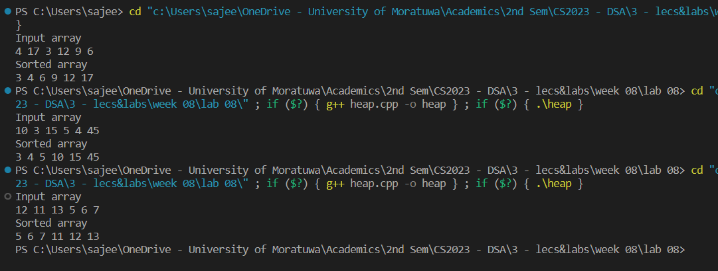

**Max-heap visualization:**

Input – 4,17,3,12,9,6

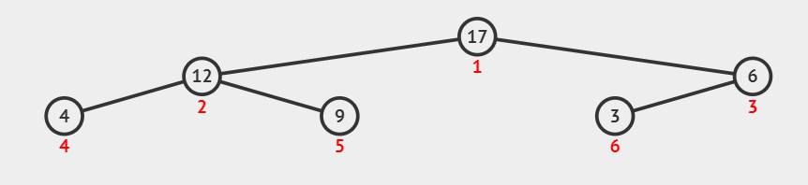

Input – 10,3,15,5,4,45

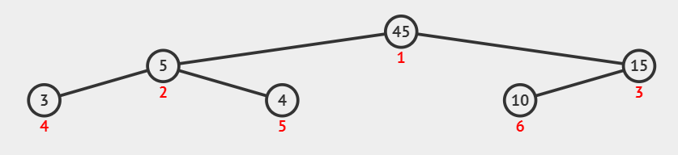

Input – 12,11,13,5,6,7

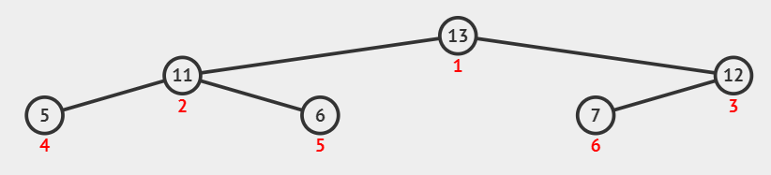

**Discussion:**

Heap sort uses comparison method for sorting. It builds a binary heap from the input array in order to be sorted. The heapify operation takes O(logn) time complexity for an n sized input array. And we do it n times for each element from the input array. So the time complexity of the heap sort will be like this,

* Best case: O(nlogn)
* Average case: O(nlogn)
* Worst case: O(nlogn)